Item | Needed | Present | Item | Needed | Present | Item | Needed | Present
Small Rubber Belt  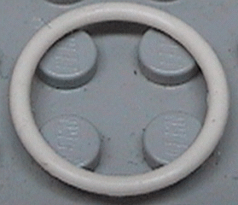  (White) | 2 |  | 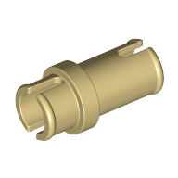  Technic, Pin ¾  (Cream) | 6 |  | 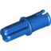  Technic, Axle Pin with Friction Ridges Lengthwise  (Blue) | 57
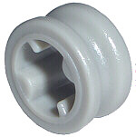  Technic Bush  (Gray) | 16 |  | 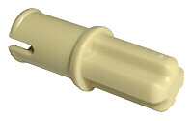  Technic, Axle Pin without Friction Ridges Lengthwise  (Cream) | 6 |  | 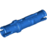  Technic, Pin Long with Friction Ridges Lengthwise  (Blue) | 33
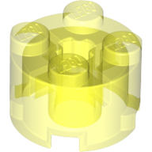  Brick, Round 2x2  (Trans-Neon Green) | 2 |  | 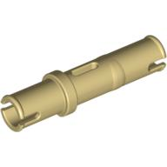  Technic, Pin Long without Friction Ridges Lengthwise  (Cream) | 14 |  | 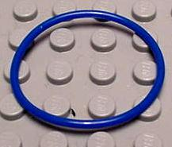  Rubber Belt Large (Round Cross Section) - Approx. 4 x 4 | 2
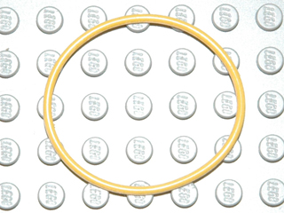  Extra Large Rubber Belt  (Yellow) | 2 |  | 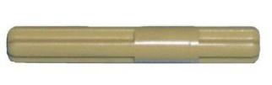  Technic, Axle 4 with Center Stop  (Cream) | 2 |  | 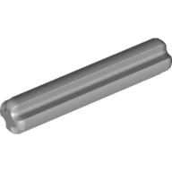  Technic, Axle 3  (Gray) | 12
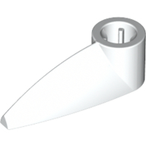  Bionicle 1x3 Tooth with Axel Hole  (White) | 1 |  | 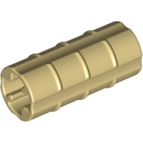  Technic, Axle Connector (Ridged with x Hole x Orientation)  (Cream) | 1 |  | 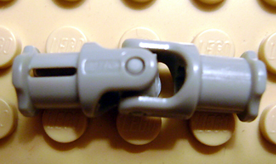  Technic, Universal Joint 3L  (Gray) | 2
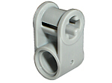  Technic, Axle and Pin Connector Perpendicular  (Gray) | 4 |  | 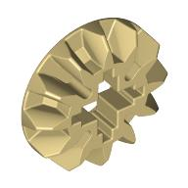  Technic, Gear 12 Tooth Bevel  (Cream) | 3 |  | 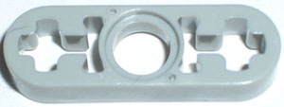  Technic, Liftarm 1 x 3 Thin  (Gray) | 10
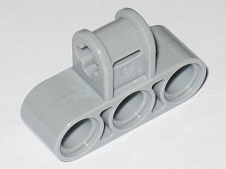  Technic, Axle and Pin Connector Perpendicular Triple  (Gray) | 2 |  | 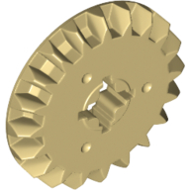  Technic, Gear 20 Tooth Bevel  (Cream) | 1 |  | 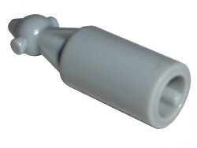  Technic, Steering CV Joint  (Gray) | 2
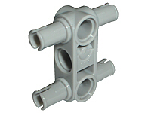  Technic, Pin Connector Perpendicular 3L with 4 Pins  (Gray) | 10 |  | 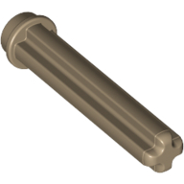  Technic, Axle 3 with Stud  (Sand Yellow) | 16 |  | 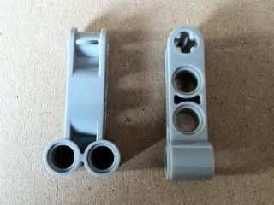  Technic, Axle and Pin Connector Perpendicular Double 4L  (Gray) | 3
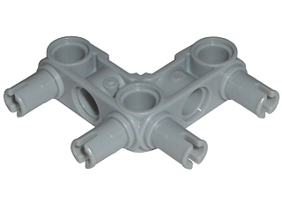  Technic, Pin Connector Perpendicular 3 x 3 Bent with 4 Pins  (Gray) | 4 |  | 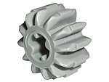  Technic, Gear 12 Tooth Double Bevel  (Gray) | 2 |  | 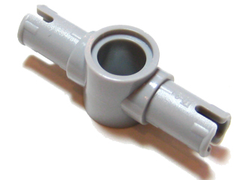  Technic, Pin Long with Friction Ridges Lengthwise and Center Pin Hole  (Gray) | 2
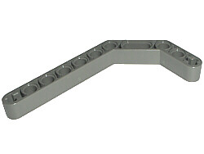  Technic, Liftarm 1 x 11.5 Double Bent Thick  (Gray) | 4 |  | 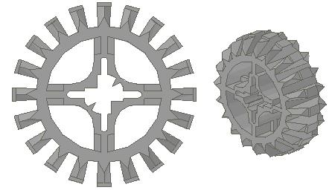  Technic, Gear 20 Tooth Double Bevel  (Gray) | 1 |  | 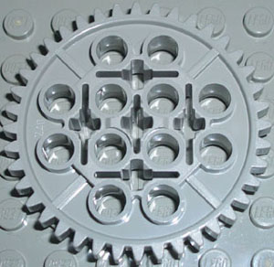  Technic, Gear 40 Tooth  (Gray) | 2
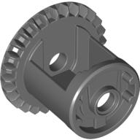  Technic, Gear Differential with Inner Tabs (Undetermined Center), 28 Bevel Teeth  (Gray) | 1 |  | 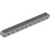  Technic, Liftarm 1 x 11 Thick  (Gray) | 6 |  | 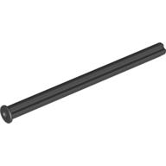  Technic, Axle 8 with Stop  (Gray) | 6
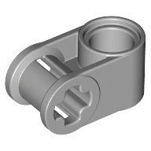  Technic, Axle and Pin Connector Perpendicular 3L with 2 Pin Holes  (Gray) | 4 |  | 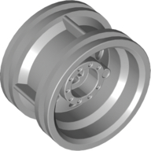  Wheel 30.4mm D. x 20mm with No Pin Holes and Reinforced Rim  (Gray) | 3 |  | 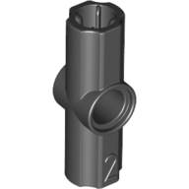  Technic, Axle and Pin Connector Angled #2 - 180 degrees  (Black) | 5
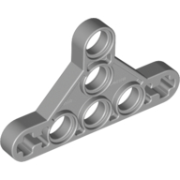  Technic, Liftarm Triangle Thin, Type II  (Gray) | 5 |  | 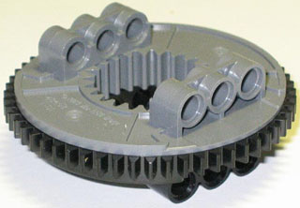  Technic Turntable Large Type 2, Complete Assembly with Black Outside Gear Section  (Gray) | 1 |  | 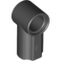  Technic, Axle and Pin Connector Angled #1  (Black) | 6
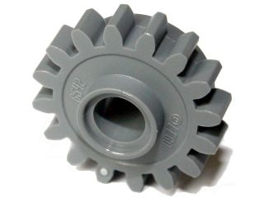  Technic, Gear 16 Tooth with Clutch, Smooth  (Gray) | 2 |  | 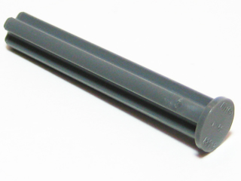  Technic, Axle 4 with Stop  (Gray) | 8 |  | 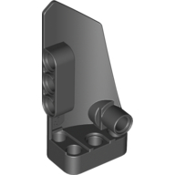  Technic, Panel Fairing # 3 Small Smooth Long, Side A  (Black) | 2
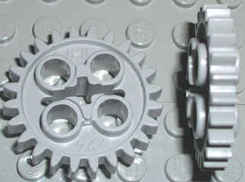  Technic, Gear 24 Tooth (New Style with Single Axle Hole)  (Gray) | 3 |  | 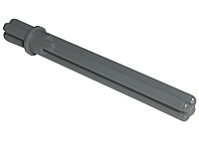  Technic, Axle 5.5 With Stop  (Gray) | 4 |  | 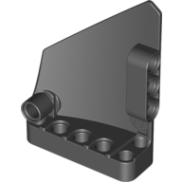  Technic, Panel Fairing #13 Large Short Smooth, Side A  (Black) | 1
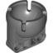  Technic, Steering Ball Joint Large Receptacle  (Gray) | 1 |  | 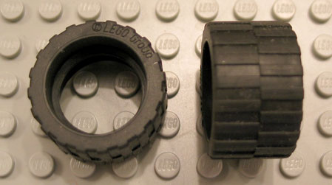  Tire 24 x 14 Shallow Tread (Tread Small Hub)  (Black) | 2 |  | 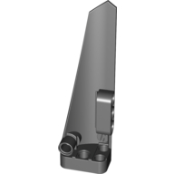  Technic, Panel Fairing # 5 Long Smooth, Side A  (Black) | 1
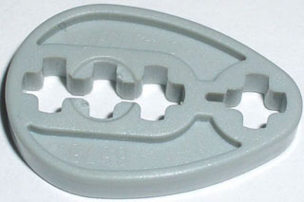  Technic Cam  (Gray) | 2 |  | 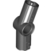  Technic, Axle and Pin Connector Angled #3 - 157.5 degrees  (Black) | 4 |  | 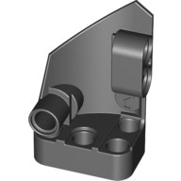  Technic, Panel Fairing # 2 Small Smooth Short, Side B  (Black) | 1
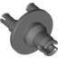  Technic, Steering Portal Axle, Hub  (Gray) | 2 |  | 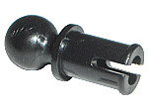  Technic, Pin with Friction Ridges Lengthwise and Towball  (Black) | 8 |  | 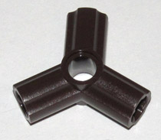  Technic, Axle and Pin Connector Triple | 5
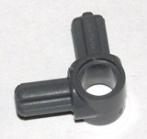  Technic, Axle and Pin Connector Hub with 2 Axles  (Gray) | 2 |  | 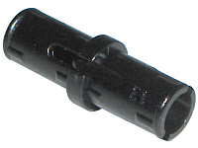  Technic, Pin with Friction Ridges Lengthwise WITH Center Slots  (Black) | 170 |  | 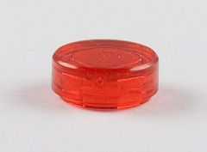  Tile, Round 1 x 1  (Trans-Red) | 6
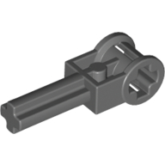  Technic Pole Reverser Handle  (Gray) | 2 |  | 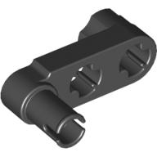  Technic, Liftarm 1 x 3 with 2 Axle Holes and Pin / Crank  (Black) | 1 |  | 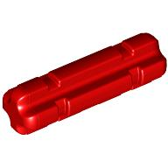  Technic, Axle 2 Notched  (Red) | 22
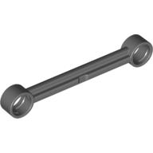  Technic, Link 1 x 6 without Stoppers  (Gray) | 2 |  | 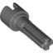  Technic, Steering CV Joint Axle  (Gray) | 2 |  | 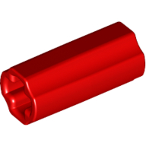  Technic, Axle Connector (Smooth with x Hole + Orientation)  (Red) | 4
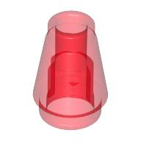  Cone 1 x 1 with Top Groove  (Trans-Red) | 4 |  | 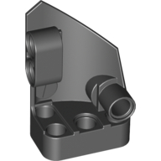  Technic, Panel Fairing # 1 Small Smooth Short, Side A  (Black) | 1 |  | 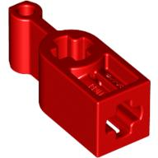  Technic Changeover Catch  (Red) | 1
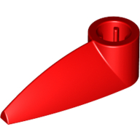  Bionicle 1 x 3 Tooth with Axle Hole  (Red) | 2 |  | 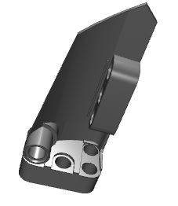  Technic, Panel Fairing # 4 Small Smooth Long, Side B  (Black) | 2 |  | 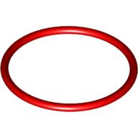  Rubber Belt Medium (Round Cross Section) - Approx. 3 x 3  (Red) | 2
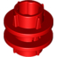  Technic Driving Ring  (Red) | 1 |  | Technic, Panel Fairing #14 Large Short Smooth, Side B  (Black) | 1 |  | 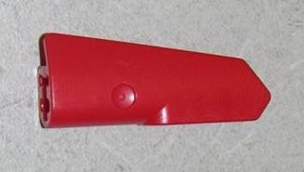  Technic, Panel Fairing #22 Very Small Smooth, Side A  (Red) | 2
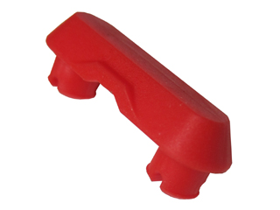  Technic, Link Tread Attachment, Rubber  (Red) | 28 |  | Technic, Panel Fairing # 6 Long Smooth, Side B  (Black) | 1 |  | 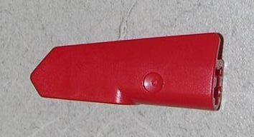  Technic, Panel Fairing #21 Very Small Smooth, Side B  (Red) | 2
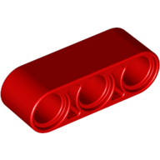  Technic, Liftarm 1 x 3 Thick  (Red) | 2 |  | 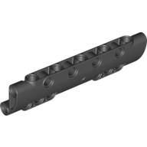  Technic, Panel Curved 11 x 3 with 10 Pin Holes through Panel Surface  (Black) | 4 |  | 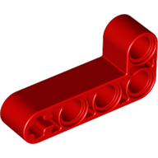  Technic, Liftarm 2 x 4 L-Shape Thick  (Red) | 4
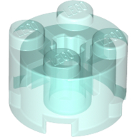  Brick, Round 2 x 2  (Trans-Light Blue) | 2 |  | 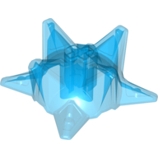  Hero Factory Weapon - Spiked Ball, Half  (Trans-Dark Blue) | 2 |  | 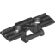  Technic, Link Tread Wide with Two Pin Holes  (Black) | 5 |  | 1
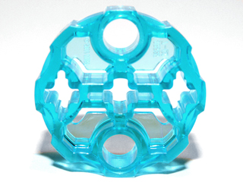  Hero Factory Weapon Barrel with 2 Pin Holes and 3 Axle Holes  (Trans-Light Blue) | 2 |  | 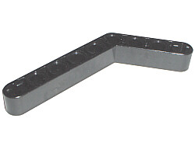  Technic, Liftarm 1 x 9 Bent (6 - 4) Thick  (Black) | 2 |  | 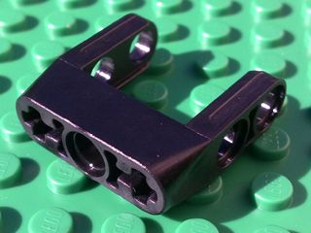  Technic, Pin Connector Toggle Joint Smooth Double with Axle and Pin Holes  (Black) | 1
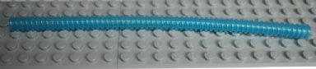  Hose, Ribbed 7mm D. 19L  (Light Blue) | 4 |  | 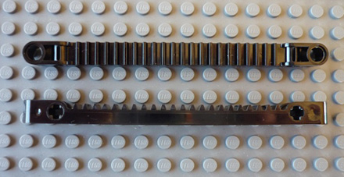  Technic, Gear Rack 1 x 13 with Axle and Pin Holes | 2

Name: __________________________________________ Time:

Date: ___________________________________________ Start time: ________________________

Kit #: ___________________________________________ End time: _________________________

